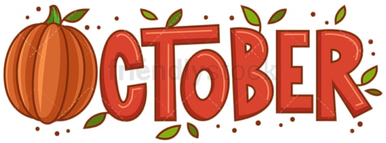
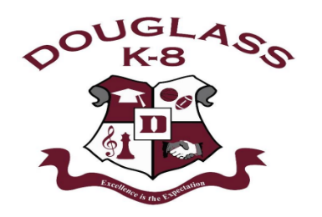
STUDENT
CALENDAR
Douglass K-8 Optional School
1650 Ash St.
Memphis, TN 38108
901-416-5946
2024-2025 School Year

Sun | Mon | Tue | Wed | Thu | Fri | Sat
-October is Breast Cancer Awareness Month  -Red Ribbon Week is Oct 20th-24th students may dress out for those designated days on the calendar.  -If your contact info changes, please notify the office.  -Student attendance each day is VERY IMPORTANT!  -Students are in uniform unless otherwise specified. |  |  | 1 | 2  Custodial Staff  Appreciation Day  Quarter 1 CFA (ELA) | 3 Last day of Quarter 1  Quarter 1 CFA (ELA) Makeup    National Smile Day! Wear smiley face attire! (NO PAJAMAS!) | 4
5 | 6  First day of Quarter 2  Instructional Coah App Day!  Quarter 1 CFA (Math/Sci) | 7  Quarter 1 CFA (Math/Sci)  Makeup | 8 | 9 | 10 PINK FRIDAY    Wear pink to honor all those who have dealt with breast cancer. | 11
12 | 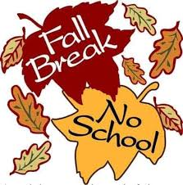  13 | 14 | 15 | 16 | 17 | 18
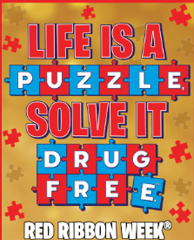  19 | 20    Basketball v Granville T Woods @ Granville T Woods 5:30pm  “Put the Pieces in Red”  Wear red to show your pledge to be drug free | 21  “Be A Key Piece”  Wear a shirt with a motivational or inspirational message to show how you contribute to the big picture! | 22  Report Card Day!  “Puzzle Piece Patterns”  Wear plaid, polka dot, stripes or patterns to represent different pieces coming together! | 23  “See The Puzzle Clearly”  Wear shades to show how you block out anything that doesn’t fit into healthy choices.  Baskbetball v Granville T Woods @ Douglass HS 5:30pm |   24 PINK FRIDAY  “Cap it Off: The Final Piece”  Wear a hat to show that you are completing the puzzle of a drug free life! | 25
26 | 27  Basketball V Journey Coleman MS @ TBA 5:30pm | 28 | 29 | 30 | 31  HALLOWEEN!

